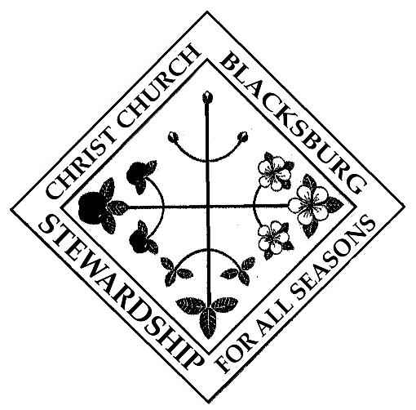
Christ Episcopal Church
Pledge Form – 2026
Did you know that an IRA distribution directed to Christ Church may offer possible tax benefits to both the church and yourself? Need more information? □
Would you like information on Planned Giving to Christ Church? □
Before returning, please fill out the Ministry Opportunities form.

Name(s): please print ___________________________________________
Address: _________________________________________________
City, State, ZIP: ___________________________________________
Name (#1): _______________________________________
Phone No.: __________________ Email Address: _____________________________________
Name (#2): _______________________________________
Phone No.: __________________ Email Address: _____________________________________
□ My contact information has changed since January 2025.

I/We pledge a total gift of $_________________ for 2026 in thanksgiving
and support of the mission and ministry of Christ Church.

I/We request pledge envelopes. Yes No (circle choice)

Please make your pledge by Stewardship Sunday – October 19, 2025

Options include:
Online: https://www.christchurchblacksburg.org/pledge
(password is invite, all lowercase)

Or return this pledge form to Karen Iannaccone,
Pledge Treasurer, by one of these methods:
- USPS Mail: P.O. Box 164,
Blacksburg, VA 24063-0164
- Email: kareniann3@gmail.com
- Drop into the Sunday collection plate
Questions: 540-998-5867 (Karen Iannaccone)

Thank you,
The Stewardship Committee & Vestry

